## 

## American International University- Bangladesh (AIUB)

## Department of Computer Science

## Software Development And Project Management

## Assignment: Mid Term Assignment

## Section : A

## Summer 2019-2020

## Project Title: Developing a Software Development Project Management Plan for Dhaka Subway Systems Automated Ticket Issuing System.

**Submitted By:**

|  |  |
| --- | --- |
| **Name** | **ID** |
| SARKER, SAYED AHMED | 17-34150-1 |
| RINKY, FATEMA FARHANA | 17-34127-1 |
| MITO, ALI HASAN | 17-34425-1 |
| KHAN, SHAKIL | 17-34130-1 |
| RASEL, ABDULLA AL MONIM | 17-34616-2 |

**Acknowledgement**

This Project was instructed and supervised by S.M. Abdur Rouf Bhuiyan Sir. The duration of this project is 10th August 2020 to 10th September 2020.

**Review**

As this is the first version of our project we called it v_1.0.0. When we change our documentations we will change the current version of our project.

**CONTENTS**

* **Title ……………………………………………………… 01**
* **Acknowledgement & Review ………………………….. 02**
* **Introduction …………………………………………….. 04**
* **Process Model**
* **Choosing Perfect Model …………………………. 04**
* **Why This Model …………………………………. 04**
* **Software Life Cycle Flowchart ………………….. 05**
* **Quality Gate For Each Phase …………………………. 06**
* **List Of Tasks ………………………………………….... 06**
* **Estimation for each task ………………………………. 07**
* **Schedule the tasks ……………………………………... 08**
* **List Of MileStone …………………………………….... 08**
* **Staffing Plan ………………………………………........ 09**
* **Monitoring and Controlling Mechanisms ………….... 10**
* **Risk Management ……………………………………... 10**
* **List of Deliverables ……………………………………. 11**
* **Defect Tracking Process …………………………….... 11**
* **Metrices ………………………………………………... 12**
* **Postmortem ……………………………………………. 13**
* **Introduction**

This is the documentation of the product venture the board plane for Automated Ticket framework for Dhaka Subway . This product Project Management Plan will clarify insights concerning the product advancement lifecycle which our gathering will take so as to finish the ideal programming item . This report will cover definite data about the administration plan used to this undertaking. The target group for this record is the architects and IT office individuals. It determines the specialized and administrative to build up the product item. Everything specialized and administrative are needed to turn over the expectations for the Dhaka Subway Systems. This incorporates booking, ID of assignments and elements that may affect the task and arranging.

* **Process Model**
* **Choosing a Perfect Model:**

We choose Rapid Application Development model(RAD). It is type of International model. It is a faster software development process. In RAD the lifecycle is 60 to 90 days to finish the whole project.

* **Why This Model:**
* It is useful cause its reduce the overall project risk.
* Flexible to changes.
* It is easier to transfer deliverables as scripts, high-level abstractions and intermediate codes are used
* To save development time ,possibly at the expensive of economy or product quality
* Each phase in RAD delivers highest priority functionality to client.
* With less people, productivity can be increased in short time
* Due to prototyping in nature, there is a possibility of lesser defects
* We have got well-defined requirement to build this software . so we planned the project and progress for the RAD model.
* **Software life cycle flow chart(RAD):**

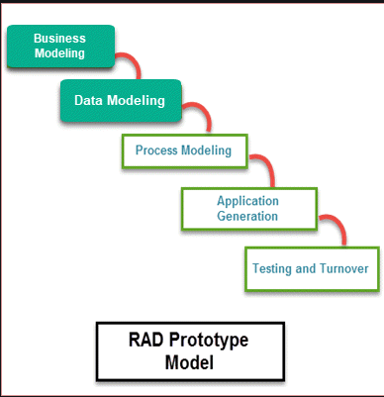

* **Quality gate for each phase of software development**

Expanded the quality is an essential focal point of the Rapid Application Development Methodology. In any case, the term has diverse implying that is customarily connected with Custom Application Development. Before RAD, Perhaps more naturally, quality being developed was both how much an application affirms to particulars and absence of imperfections once the application is conveyed. As indicated by RAD, the quality is characterized as both how much a conveyed addresses the issues of clients just as how much a conveyed framework has low upkeep cost. Fast Application Development endeavors to convey on quality through the substantial including of clients in the examination and especially the plan stages.

* **List Of Tasks**
* Requirement Collections
* Project Planning
* Requirements Analysis
* System Design
* Project Review
* Implementation by Coding
* Unit Testing
* Object Design Review
* System Integration and System Testing
* Internal Project Review
* Project Acceptance

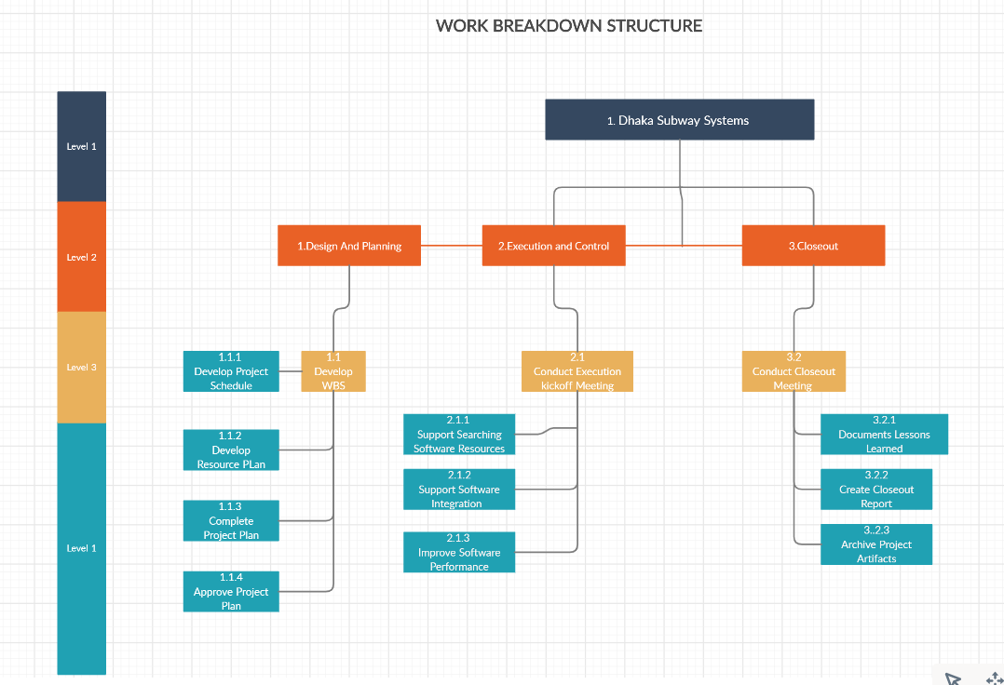

* **Estimation for each task**

|  |  |  |
| --- | --- | --- |
| **Task Of Phase** | **Days** | **Hours** |
| Requirements Collections | 7 | 7*8=56 |
| Project Planning | 16 | 16*8=128 |
| Requirement Analysis | 12 | 12*8=96 |
| System Design | 15 | 15*8=120 |
| Object Design | 10 | 10*8=80 |
| Implementation | 10 | 10*8=80 |
| Unit Testing | 5 | 5*8=40 |
| System Integration and System Testing | 15 | 15*8=120 |

**Note:** Each engineer works for 8 hours a day and 5 days a week. Total project duration is 90 working days.

* **Schedule the tasks**

|  |  |
| --- | --- |
| **Date** | **Phases** |
| Sep 1 to Sep 7 | Requirements Collections |
| Sep 8 to Sep 24 | Project Planning |
| Sep 25 to October 6 | Requirement Analysis |
| October 7 to October 22 | System Design |
| October 22 to November 2 | Object Design |
| November 3 to November 13 | Implementation |
| November 14 to November 19 | Unit Testing |
| November 20 to December 5 | System Integration and System Testing |

**Note:** Some weekends are included in the time frame which is not counted as working days. We assume that only 80% time of an engineer per day will be used to develop software. Other 20% will be spending by reading emails, attending meetings, process improvement activities etc.

* **List Of Milestones**

|  |  |
| --- | --- |
| **Date** | **Milestones** |
| Sep 7 | Presentation done By Dhaka Subway System for Requirements |
| Sep 24 | Analysis Review Done |
| Sep 25 to October 6 | Requirement Analysis Done |
| October 22 | Project Review With Dhaka Subway System |
| November 2 | Object Design Review |
| November 13 | Dummy Product Review |
| November 19 | Testing Done |
| December 5 | Project Delivered to Dhaka Subway System. |

* **Staffing Plan (Assign tasks to Software Engineers)**

|  |  |
| --- | --- |
| **Person** | **Rational Unified Process Role** |
| Project Manager | [Project Manager](https://sceweb.uhcl.edu/helm/RationalUnifiedProcess/process/workers/wk_projm.htm) [Deployment Manager](https://sceweb.uhcl.edu/helm/RationalUnifiedProcess/process/workers/wk_depm.htm) [Requirements Reviewer](https://sceweb.uhcl.edu/helm/RationalUnifiedProcess/process/workers/wk_reqrv.htm) [Architecture Reviewer](https://sceweb.uhcl.edu/helm/RationalUnifiedProcess/process/workers/wk_arvwr.htm) [Configuration Manager](https://sceweb.uhcl.edu/helm/RationalUnifiedProcess/process/workers/wk_cmmgr.htm) [Change Control Manager](https://sceweb.uhcl.edu/helm/RationalUnifiedProcess/process/workers/wk_ccmgr.htm) |
| VP Operations | [Project Reviewer](https://sceweb.uhcl.edu/helm/RationalUnifiedProcess/process/workers/wk_prrev.htm) [Requirements Reviewer](https://sceweb.uhcl.edu/helm/RationalUnifiedProcess/process/workers/wk_reqrv.htm) |
| Senior Software Engineer | [System Analyst](https://sceweb.uhcl.edu/helm/RationalUnifiedProcess/process/workers/wk_sysan.htm) [Requirements Specifier](https://sceweb.uhcl.edu/helm/RationalUnifiedProcess/process/workers/wk_ucaut.htm) [User Interface Designer](https://sceweb.uhcl.edu/helm/RationalUnifiedProcess/process/workers/wk_uides.htm) [Software Architect](https://sceweb.uhcl.edu/helm/RationalUnifiedProcess/process/workers/wk_archt.htm) [Design Reviewer](https://sceweb.uhcl.edu/helm/RationalUnifiedProcess/process/workers/wk_desrv.htm)  [Test Manager](https://sceweb.uhcl.edu/helm/RationalUnifiedProcess/process/workers/wk_tstmng.htm)  [Test Analyst](https://sceweb.uhcl.edu/helm/RationalUnifiedProcess/process/workers/wk_tstanl.htm) |
| Software Engineer  Junior Software Engineer  Software Engineer  Junior Software Engineer | [Designer](https://sceweb.uhcl.edu/helm/RationalUnifiedProcess/process/workers/wk_dsgnr.htm) [Implementer](https://sceweb.uhcl.edu/helm/RationalUnifiedProcess/process/workers/wk_implm.htm) [Code Reviewer](https://sceweb.uhcl.edu/helm/RationalUnifiedProcess/process/workers/wk_codrv.htm) [Integrator](https://sceweb.uhcl.edu/helm/RationalUnifiedProcess/process/workers/wk_syint.htm) [Test Designer](https://sceweb.uhcl.edu/helm/RationalUnifiedProcess/process/workers/wk_tstds.htm) [Tester](https://sceweb.uhcl.edu/helm/RationalUnifiedProcess/process/workers/wk_tstr.htm) [Technical Writer](https://sceweb.uhcl.edu/helm/RationalUnifiedProcess/process/workers/wk_tchwr.htm) |

* **Monitoring and Controlling Mechanisms**

Monitoring of process is done by the Project Manager using the following means:

* Weekly Project Meeting will happen at the lead venture supervisor's room.
* Meeting are held Tuesday at 11 am and educate each other of the advancement made on the different errands. New errands are allocated by the Project Manager during these gatherings. Before venture bunch gatherings, the Project Manager will peruse the minutes of significant past gatherings and make a plan for the gathering. Colleagues can propose extra plan focuses previously or during the gathering.
* These gatherings are booked once in seven days. During these gatherings, the Project Manager and Quality Assurance Manager meet with the Senior Management. The accompanying things should be done before an advancement meeting:
* A progress report of the last announcing period is composed by the Project Manager.
* The Project Manager and Quality Assurance Manager read the minutes of the past gathering.
* A printed copy rendition of the advancement report is conveyed to the Senior Management.
* **Risk Management**

This mentions a number of possible risk of the project. Also actions or measures are described to prevent or to reduce the risks.

* **Communication collapse:** There is an opportunity to break in correspondence between the colleagues or backers. In the event that this occur, it might lead or falling behind. In the event that it occur, at that point we will attempt to arrive at that partner. On the off chance that they become inaccessible for a period being. We will redistribute the works.
* **Hardware incapacity-** Quite possibly the organization worker could fall previously, during or after arrangement of our product. In the event that this occur, at that point no arrangement will come, it implies this task will incapable to convey to the support. All essential recuperation steps will be taken as quickly as time permits.
* **Defect at modeling/ planning-** If any defect found during the project in our planning or modeling then the project will demand more time to complete.
* **Political crisis-** In Case of strike or any other political issues our workers will work on weekend or in the holiday.
* **List of Deliverables**

Software Project Management Plan defining the technical and managerial processes necessary for the development and delivery of the system (This document).

* Agreement between Bangladesh Road Transport Corporation (BRTC) and developers, representing a contract between the BRTC and the developers of what is going to be delivered.
* Analysis Document describing the functional and global Requirements of the system of 4 models. The use case model, the object model, the functional model and the dynamic model.
* System Design describing design goals, the high level decomposition of the system, concurrency identification, hardware/ software platforms, data management, global resource handling, software control implementation and boundary conditions. This document forms the basis of the object design.
* Object Design is composed of two documents. The first document is an update RAD. The code related data will be in the form of java output from the code from each team.
* Test Manual describing the unit and system performed on the system before delivery along with expected results.
* **Defect Tracking Process**

There can be taken some precautionary measurements to track defect. Those measurements are given below:

* Breakdown the entire execution system into a few sections and examines each part meticulously to find surrenders.
* While coding stage begins, consistently watch that the usage is really being founded on necessities.
* Prerequisites delineated by the Dhaka Subway System partners ought to be kept up and refreshed consistently.
* There ought to be agreeable measure of connection between the coder and the task chief to guarantee the nature of the framework.
* The task supervisor must be impart towards the partners of the Dhaka Subway System.
* **Metrices**

|  |  |  |
| --- | --- | --- |
| Schedule | Milestones | MS Project |
| Staff Usage | Graph of person hrs used per month both projected and actual | MS Excel |
| Expenditures | Graph of total expenditures over time both projected and actual | MS Excel |
| No. Of Requirements | Graph of total requirements identified per module over time | MS Excel |
| No. Of requirements defects | Graph of number of defects identified per module over time | MS Excel |
| No. Of objects | Graph of number of objects identified Over time | MS Excel |
| Coding Progress | Number of Objects coded | MS Excel |
| Coding Size | Lines of code measured daily | MS Excel |
| Test Progress | Unit Test causes passed over time | MS Excel |
| Defect Tracking | Number of code defects |  |
| Test Progress | Number of integration test passed over time | MS Excel |
| Defect Tracking | Number of code defects test passed over time | MS Excel |

* **Postmortem**

The Overall undertaking plan follows the model, a changed RAD model. 3 prtotypes must be conveyed: A graphical UI, prototype model and a framework mix model. Examination is begun before Project Planning is done. Framework Design is trailed by object Design. We trust that we will be to finished this task effectively with no significant interference.